Kirkcudbright Walks : Dee Walk and Tongland  Walk Details  Distance Approx. time Height gain OS Map  7.5km 2.5 hours - Landranger 83  Location  Kirkcubright, off the A75 Dumfries to Stranraer road.  Start Point  Selkirk Arms Hotel  Description  From the car park, turn right onto the main road then left. Make your way straight through the town, taking the 2nd left heading for Kirkcudbright Bridge. This bridge was constructed in 1926 to replace an iron structure. Before the bridge was built, the River Dee was crossed by ferry which, because of the tidal nature of the water here and the very strong currents, could be difficult and dangerous. On reaching the bridge head right along Dee Walk. Follow the path along the river through the park area where, at the ned, you will cross a bridge over the Boreland Burn. Turn left on to the flood bank protecting the low lying fields to your right.  If you go quietly along your way, you are likely to see a great number of birds, including estuarine feeders such as oystercatcher, curlew redshank and grey heron. Depending on the time of year, you are also likely to see duck species such as tufted duck and goldeneye. There will nearly always be a cormorant looking for good fishing and there is also the chance of seeing an otter. As you round the bend to where the Tarff Water joins the River Dee, there are extensive reed beds. These are an attractive safe haven for wildlife, including sedge warblers, which can be heard chattering amongst the reeds in summer. Looking across the water, the rather grand red sandstone house you can see is Cumstoun House, a private dwelling. In its grounds is the ruin of Cumstoun Castle, a tower house built around the 15th century.  Continuing along the path, you enter a riverside woodland. This change in environment brings in small birds such as blue and great tits, great spotted woodpeckers, treecreepers and the ubiquitous wren. Once you reach Tongland Bridge, carefully cross the road and climb the stile at the other side. The path takes you along the riverside, where you have a view of the bridge. Tongland Bridge was built from a design by Thomas Telford, the famous road and bridge builder, at a cost of £7000. The first foundations laid on 1804, were washed away and the following year, work restarted and the bridge completed and opened in 1808. As the river at this point has a remarkable tidal rise of some 20 feet, each of the bridge approaches has three tall flood arches to assist the flow of water at high tides. The remains of the old railway bridge can be seen upstream.  Continue alongside the river, passing under the arch of the old railway bridge, with Tongland Power Station in front of you. Further upstream from here is the Tongland Dam and reservoir. Beyond the railway arch, follow the path alongside the river and into a strip of woodland and comes out at Tongland Old Bridge, over the old river bed of the Dee. Cross the bridge and walk up the minor road to join the A7111. | 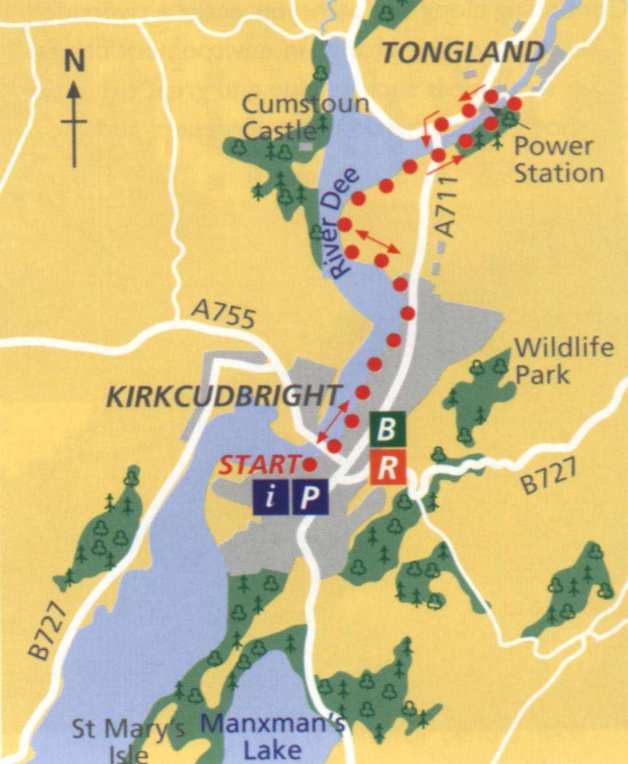  Turn left and walk along the pavement towards the Power Station. There is a visitor centre here and an exhibition, refreshments and guided tours. Follow the pavement past the visitor centre back to Tongland Bridge where you can retrace your steps along the Dee Walk.

