Kirkcudbright Walks : Balcary to Rascarrel  Walk Details  Distance Approx. time Height gain OS Map  Option 1: 2.5km Option 2: 7.5km Option 1: 1 hour Option 2: 4 hours - Landranger 84  Location  Balcary Bay, 1km south of Auchencairn.  Start Point  Parking is available in the car park just past Balcary Bay Hotel. To get there from Auchencairn, follow the signs for Balcary which take you down a narrow road for two miles. You will pass the Bowling Green on your left and soon the views over the bay open up and Hestan Island is prominent to the south east. The road terminates at the car park where an information board tells you about the area.  Description  Start from the car park. At the far end there is a track signed Balcary Point and Rascarrel. Follow this for about 150 yards until you reach a kissing gate and a further sign to the right of the gate. Go through the kissing gate and bear left, follow the track along the edge of the field. Take time to enjoy the views over Auchencairn Bay and back towards Screel and Bengairn. Very often there are sheep and cattle in this field so dogs must be kept under close control. Go through the kissing gate at the end of the field and along the path which passes along the edge of the woodland. The path takes you past Boat House, the former Lifeboat Station, and eventually brings you onto the gentle slopes of Balcary Point.  Depending on the time of the year, the grassland flowers here include violets, primroses, heath spotted orchid and birdsfoot trefoil. Continue to follow the path round. You are now approaching the higher cliff-top section of the path. In May and June the upper parts of the cliffs are alive with nesting sea birds jostling and noisily contesting for prime sites. On the lower slopes guillemots, razorbills and kittiwakes make their home. There are also many cormorants nesting - you will probably hear, or smell them before you see them. In spring you cannot help but notice the wildflowers which cling to the cliffs, creating a profusion of colour. These hanging gardens are made up mainly of sea campion, thrift, which forms dense cushions, scurvy grass and the low growing and creeping stonecrop and birdsfoot trefoil. | 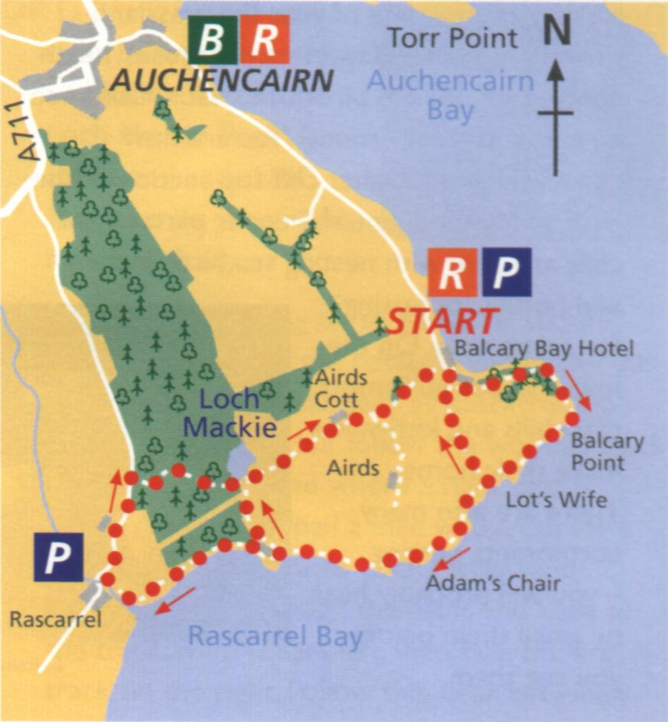
Option 1 - Head up right, behind the cottages and follow the path to loch Mackie. Turn right at the end and after about a mile you will be back at Balcary.  Option 2 - When you reach the metal kissing gate, you can if you wish return to Balcary by the permissive path kindly provided by the farmer. To continue the walk follow the path down on to the shore at a point near the ruined buildings of an old bartyres mine. Continue until you reach the cottages where another option becomes available. Those who are carrying on to Rascarrel should bear left in front of the cottages and follow the track round to the car park at Rascarrel. | Do not cross the burn but follow the wooden track up to the public road where a right turn is made. After about a half a mile watch out for a signpost on the right to Loch Mackie and Balcary. Turn in through the gates and keep to the track, which bears left, then take the first track on the right. Follow this, bear left where and arrow is pointing to Loch Mackie. At times, detours may be in place due to forestry operations. This brings you to the footbridge over the outlet from the loch. It is possible to see mallard and tufted duck on the loch and there is usually the odd cormorant around looking for good fishing. This loch is man-made and your route lies across the top of the dam ¿ through the kissing gate and straight on for your return to Balcary.

